John 6: 51 - “I am the living bread that came down from heaven. Whoever eats this bread will live forever. This bread is my flesh, which I will give for the life of the world”
Who is Christ for us today?
- Does this ‘I am’ saying have relevance today?
- How would you explain what it means to believe that Jesus is the Bread of Life? Jesus said that He is Bread of Life. What he meant was that…
- What do you feel the Church might be in danger of forgetting about Christ?

Nurturing our Faith
Bible Study Group 2022

Who is Christ for us today?

9th May 2022
Fleet URC & Beacon Hill URC

Who is Christ for us today?
The teaching of Jesus was always relevant and meaningful to his audience. He used metaphors and analogies that would have struck powerful chords with those who heard them, to help him reinforce a particular point.
Nearly 2000 years later, from the cell where he had been imprisoned, theologian Dietrich Bonhoeffer thought and wrote about his faith. In one of the letters he wrote from prison he urged his readers to consider the importance of regarding Jesus not only as a historical figure, or even a biblical character, but as a living person in the world today.
Who is Christ really for us today? he thought was one of the most important questions we could ask ourselves. Perhaps we can continue to use metaphors that make sense in our context.
Opening prayer led by Karen
The ‘I am’ sayings
We will be looking at the metaphors Jesus used about himself in the ‘I am’ sayings in John’s Gospel in exploring Who is Christ for us today?
Where Jesus says: “I am…”. Those descriptions of Jesus help us understand him and know him, so that we can put our faith in him.
We are starting today with the Bread of life.
Bread of Life | John 6: 35  35 Then Jesus declared, “I am the bread of life. Whoever comes to me will never go hungry, and whoever believes in me will never be thirsty.”

What do these phrases mean to you?
- I am
Exodus 3:14-15
"God said to Moses, 'I AM WHO I AM': This is what you are to say to the Israelites, 'I AM has sent me to you... This is My name forever, the name by which I am to be remembered from generations to generation."
- The bread of life
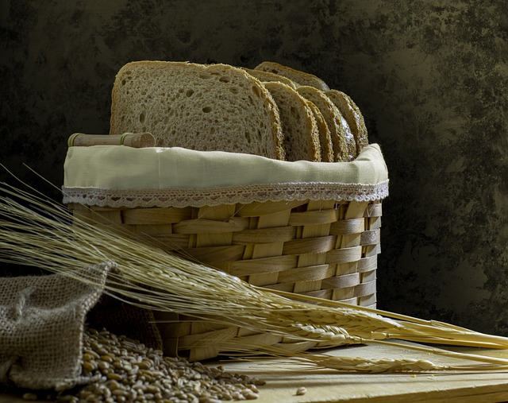
This picture of Jesus as the bread of life is pictured in the Old Testament (because New Testament truth concerning Jesus is often pictured in some form in the Old!). The Jews listening to Jesus touched on one example:
John 6:31-33
Our forefathers ate the manna in the desert; as it is written: 'He gave them bread from heaven to eat.' " Jesus said to them, "I tell you the truth, it is not Moses who has given you the bread from heaven, but it is my Father who gives you the true bread from heaven. For the bread of God is he who comes down from heaven and gives life to the world."
- What do you know about manna?

