[time for quiet prayers]

We thank you Father God, for the light and the salvation
brought through Christ, and we join in the prayer of Simeon:

‘Sovereign Lord, as you have promised,
you may now dismiss your servant in peace.
For my eyes have seen your salvation, which you have prepared in the sight of all nations: a light for revelation to the Gentiles, and the glory of your people Israel.” Amen

Hymn: R&S 600 Christ is the world’s light
Blessing

Image: https://www.churchofjesuschrist.org/media/image/bible-video-christ-presentation-temple-30f4bb1?lang=eng
Worship for Beacon Hill URC & Fleet URC
Sunday 30th January 2022
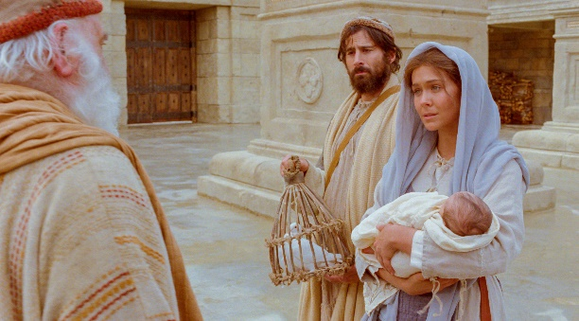
'The presentation’
Led by Karen Smith
Welcome & Gathering Prayer by Christine Allen
Call to worship

The Lord is the strength of my life
The Lord is my light and my salvation
Jesus Christ is the light of the world
All: A light which no darkness can quench
http://www.thisischurch.com/prayer_worship/liturgy/candlemas2004.htm

Hymn: R&S 181 Of the father’s love begotten

Prayers of praise & confession

Lord’s Prayer

Reading: Luke 2: 22 – 40

When the time came for their purification according to the law of Moses, they brought him up to Jerusalem to present him to the Lord (as it is written in the law of the Lord, ‘Every firstborn male shall be designated as holy to the Lord’), and they offered a sacrifice according to what is stated in the law of the Lord, ‘a pair of turtle-doves or two young pigeons.’

Now there was a man in Jerusalem whose name was Simeon; this man was righteous and devout, looking forward to the consolation of Israel, and the Holy Spirit rested on him. It had been revealed to him by the Holy Spirit that he would not see death before he had seen the Lord’s Messiah. Guided by the Spirit, Simeon came into the temple; and when the parents brought in the child Jesus, to do for him what was customary under the law, Simeon took him in his arms and praised God, saying, ‘Master, now you are dismissing your servant in peace, according to your word; for my eyes have seen your salvation, which you have prepared in the presence of all peoples, a light for revelation to the Gentiles and for glory to your people Israel.’ And the child’s father and mother were amazed at what was being said about him.

Then Simeon blessed them and said to his mother Mary, ‘This child is destined for the falling and the rising of many in Israel, and to be a sign that will be opposed so that the inner thoughts of many will be revealed—and a sword will pierce your own soul too.’

There was also a prophet, Anna the daughter of Phanuel, of the tribe of Asher. She was of a great age, having lived with her husband for seven years after her marriage, then as a widow to the age of eighty-four. She never left the temple but worshipped there with fasting and prayer night and day. At that moment she came and began to praise God and to speak about the child to all who were looking for the redemption of Jerusalem.

When they had finished everything required by the law of the Lord, they returned to Galilee, to their own town of Nazareth. The child grew and became strong, filled with wisdom; and the favour of God was upon him.

This is the Word of the Lord Thanks be to God
Hymn: R&S 127 Hail to the Lord’s Anointed

Dedication of the Offering

Address

Intercessory Prayer
Christ, who brought light to the world; shine your light in these areas of darkness.
Mary and Joseph brought doves to be sacrificed in the temple, the sacrifice
that was demanded of those too poor to afford a lamb.
Christ, you knew poverty on earth and understand the pain and suffering that it brings.
ALL: Shine your light in situations of poverty.
[time for quiet prayers]

Simeon prophesied and told Mary in the temple: ‘‘This child is destined to cause the falling and rising of many in Israel, and to be a sign that will be spoken against, so that the thoughts of many hearts will be revealed. And a sword will pierce your own soul too.’
Christ, you knew conflict on earth and experienced the violence and the hurt that it brings.
ALL: Shine your light in situations of conflict
[time for quiet prayers]

Simeon praised the Father as he met the Christ child, he prayed ‘For my eyes have seen your salvation, which you have prepared in the sight of all nations.’ Christ, you saw on earth how in need of salvation humanity were, and still is, and you wept.
ALL: Shine your light in situations of spiritual darkness

