Advent 2021
Beacon Hill URC & Fleet URC

Image by Couleur from Pixabay
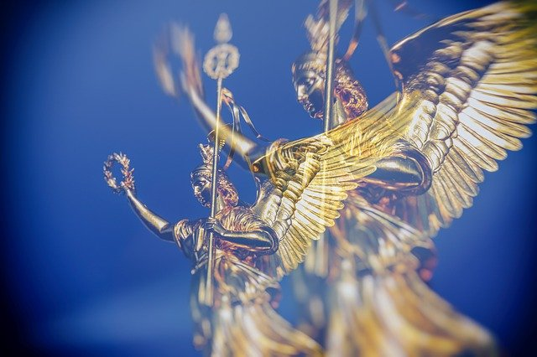

ANGELS FROM THE REALMS OF
GLORY
An Advent Candle lighting reflection

Welcome to Advent 2021
Throughout the Advent period, both Fleet URC and Beacon Hill URC will be including a short time of reflection as part of the opening section of worship based on the carol Angels from the realms of glory.
James Montgomery (1771 – 1854)
Angels from the realms of glory
Wing your flight over all the earth
Ye, who sang Creation's story
Now proclaim Messiah's birth
Come and worship, come and worship
Worship Christ the newborn King
Shepherds in the fields abiding
Watching over your flocks by night
God with man is now residing
Yonder shines the Infant light
Come and worship, come and worship
Worship Christ the newborn King
Sages leave your contemplations
Brighter visions beam afar
Seek the great Desire of Nations
Ye have seen His natal star
Come and worship, come and worship
Worship Christ the newborn King
Saints before the altar bending
Watching long in hope and fear
Suddenly the Lord, descending,
In His temple shall appear
Come and worship, come and worship
Worship Christ the newborn King
‘Angels from the realms of glory’ 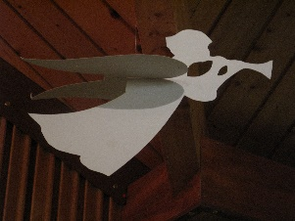
Welcome to Advent 2021!
Here we are once again, celebrating the arrival of God with us as the baby born in Bethlehem. Another year gone – and what a year! As we meet in fellowship in our individual churches, we enter another Advent season acknowledging the joy of being able to do just that.
Advent candle reflection
Beacon Hill URC and Fleet URC will have a joint Advent candle reflection, covering the Sundays in Advent until Christmas Day which will open the weekly service. We will join together using the wonders of technology on the first Sunday of Advent and share the reflection, gathering as a host of God’s disciples to mark the beginning of the season. In the following weeks we will each worship in our own church, sharing the same opening reflection whilst worshiping separately. Our theme is based on the well - known hymn ‘Angels from the realms of glory’.
A verse from the hymn:
We will sing a single verse of the hymn each week, culminating in singing the whole hymn on Christmas Day.
A reading from Scripture:
Having sung the verse for the week we will hear a short Bible reading related to that verse.
Candle lighting words:
This is followed by a time of reflective prayer to enable us to focus on the reading and the message of the angels it contains, as we light the candles in our church.
Something to read and reflect upon each week:
When you have time to pause in the busyness attached to preparing for Christmas, there is a compilation of readings, poems and prayers related to each week’s reflection available in this booklet for you to read and think about. There is a question to give you pause for thought.
Prayer Group
The online prayer group will meet via Zoom for a half hour of contemplative prayer on Monday December 13th at 11 a.m., guided by Margaret Tracey. An invitation will be sent out to join the group by email.
Monthly group ‘Nurturing your faith’ through Bible Study
The monthly meetings in the autumn have been exploring the prophetic words relating to the coming of the Messiah in the Book of Isaiah. On December 6th at 11 a.m. we will be reading and celebrating some of the songs of Christmas expressed in Luke’s Gospel. This is an online meeting too; an invitation with the joining details will be sent out by email in advance of the meeting.
Advent 1 Sunday November 28th
Angels from the Realms of glory: verse 1
Angels from the realms of glory
Wing your flight over all the earth
Ye, who sang Creation's story
Now proclaim Messiah's birth
Come and worship, come and worship
Worship Christ the newborn King
Luke 1: 26 - 38
²⁶In the sixth month the angel Gabriel was sent by God to a town in Galilee called Nazareth, ²⁷to a virgin engaged to a man whose name was Joseph, of the house of David. The virgin’s name was Mary. ²⁸And he came to her and said, “Greetings, favoured one! The Lord is with you.” ²⁹But she was much perplexed by his words and pondered what sort of greeting this might be. ³⁰The angel said to her, “Do not be afraid, Mary, for you have found favour with God. ³¹And now, you will conceive in your womb and bear a son, and you will name him Jesus. ³²He will be great and will be called the Son of the Most High, and the Lord God will give to him the throne of his ancestor David. ³³He will reign over the house of Jacob forever, and of his kingdom there will be no end.”
³⁴Mary said to the angel, “How can this be, since I am a virgin?” ³⁵The angel said to her, “The Holy Spirit will come upon you, and the power of the Most High will overshadow you; therefore the child to be born will be holy; he will be called Son of God. ³⁶And now, your relative Elizabeth in her old age has also conceived a son; and this is the sixth month for her who was said to be barren. ³⁷For nothing will be impossible with God.” ³⁸Then Mary said, “Here am I, the servant of the Lord; let it be with me according to your word.” Then the angel departed from her.
Candle lighting
Advent God, you enter time and lives
and transform both
to the glory of your name
and the benefit of all people.
On this first Sunday of Advent
we praise your name
for Angel voices
and obedient hearts.
Amen
Adapted from https://www.faithandworship.com/Advent/Advent_Angels.htm#gsc.tab=0

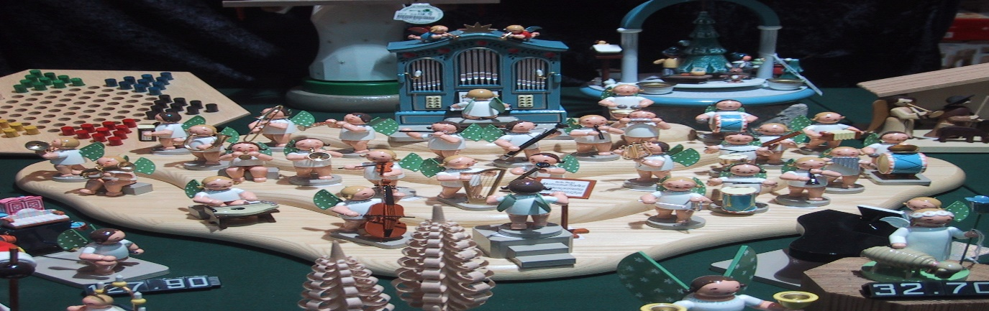

AT HOME
A prayer…………
Amidst the chores and hassle……..
Lord God, made known in Jesus
and present through your Spirit,
this Advent-tide we might look for you
by scanning the horizon,
or watching for a visitor at the door,
or by waiting for a notification to pop up on a screen…..
Alternatively, we might notice you
already beside us as we labour over a mountain
of Christmas cards – and rekindle friendships and re-affirm our love.
In stretching our minds and finances to offer suitable gifts,
might we remember that our Christmas giving
is triggered by your gift of yourself to us?
As we hear again familiar stories from far away and long ago,
may our giving and our loving be refreshed by our knowing once again
that you are here for us, then and now, and forever. Amen.
Ian Fosten URC Prayer Handbook ‘Prayers from the Heart’ 2020

A thought……
17. Angels and messengers
Advent is a season of angels – Gabriel appears to Mary, Joseph and Zechariah; a heavenly host appears to the shepherds on Christmas nigh – but there are no angels in Narnia. Perhaps this is a bit surprising in a land of unicorns, naiads and wraiths, but for the most part Lewis overtly biblical figures or imagery in his Narnia books.
In both Hebrew and Greek the word for angel is the same word as messenger. Angels have many ways of serving God, according to Scripture, and carrying messages to human beings is an important one.
The Robin is very much like an angel, a winged messenger in the service of Aslan, guiding the children to safety and help but also calling them to follow Aslan, even though they don’t even know his name yet. Like Mary, they say yes, even though they cannot know what lies ahead………
Have you ever felt God leading you in a direction you didn’t expect? Advent in Narnia: reflections for the season by Heidi Haverkamp

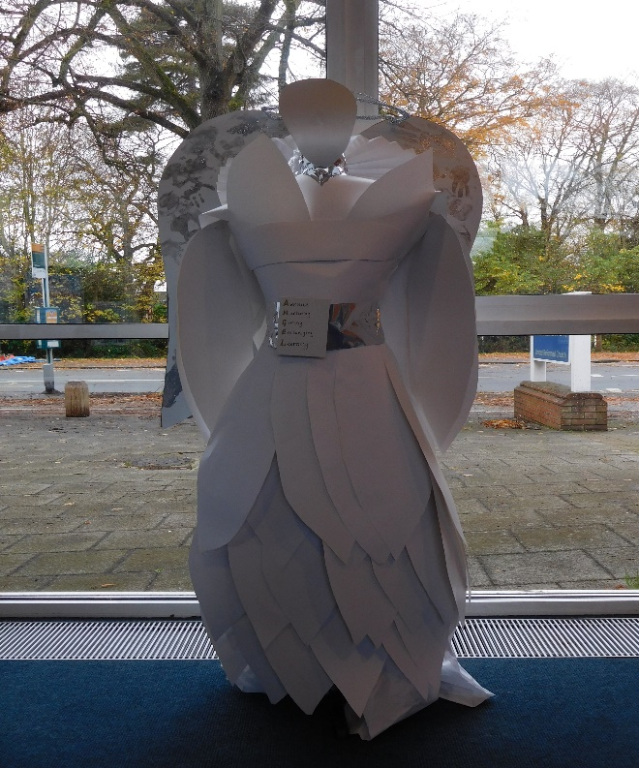

Advent 2 Sunday December 5th
Angels from the Realms of glory: verse 2
Shepherds in the fields abiding
Watching over your flocks by night
God with man is now residing
Yonder shines the Infant light
Come and worship, come and worship
Worship Christ the newborn King
Luke 2: 8 - 15:
8 In that region there were shepherds living in the fields, keeping watch over their flock by night. 9Then an angel of the Lord stood before them, and the glory of the Lord shone around them, and they were terrified. 10But the angel said to them, “Do not be afraid; for see—I am bringing you good news of great joy for all the people: 11to you is born this day in the city of David a Saviour, who is the Messiah, the Lord. 12This will be a sign for you: you will find a child wrapped in bands of cloth and lying in a manger.”
13And suddenly there was with the angel a multitude of the heavenly host, praising God and saying, 14“Glory to God in the highest heaven, and on earth peace among those whom he favours!” 15When the angels had left them and gone into heaven, the shepherds said to one another, “Let us go now to Bethlehem and see this thing that has taken place, which the Lord has made known to us.”
Candle Lighting
In the ordinary moments of our lives
When thoughts, distractions
And busyness might keep us apart
Open our hearts to let you in

Advent God, you enter time and lives
and transform both
to the glory of your name
and the benefit of all people.
On this second Sunday of Advent
we praise your name
for Angel voices
and obedient hearts.
Amen
Adapted from https://www.faithandworship.com/Advent/Advent_Angels.htm#gsc.tab=0

AT HOME
A prayer……..
God who sends angels to care for us
We thank you for the many times
Small gestures of compassion and kindness
have meant so much to us.
The smile of acceptance,
The gentle touch of reassurance,
The phone call at the ‘right’ time.
Lord we pray,
Even though we may not immediately
recognise your angels,
Enable us to be alert to their presence,
And may you use us to be angels to others. Amen by Ruth Dillon

A thought……
The shepherds were eager to respond. Not for them a long period of heart searching, agonising over what they should or shouldn’t do. Not for them shilly-shallying over the fine print, weighing up the pros and cons before dipping their foot into the water. They’d heard the good news and wanted to respond as quickly as they could. Why wait, why hang around, they reasoned? What could be gained through any delay? Here was something special, wonderful and they wanted to be part of it.
Advent calls us in turn to respond to God’s coming in Christ; to make up our minds what his living, dying and rising means for us today. It calls us to commit our lives to him, to find forgiveness and to receive new life. And it calls us to more besides….
Did you put off making a decision before you first became a Christian or did you respond immediately? If the former, what factors held you back?
Ready and waiting by Nick Fawcett

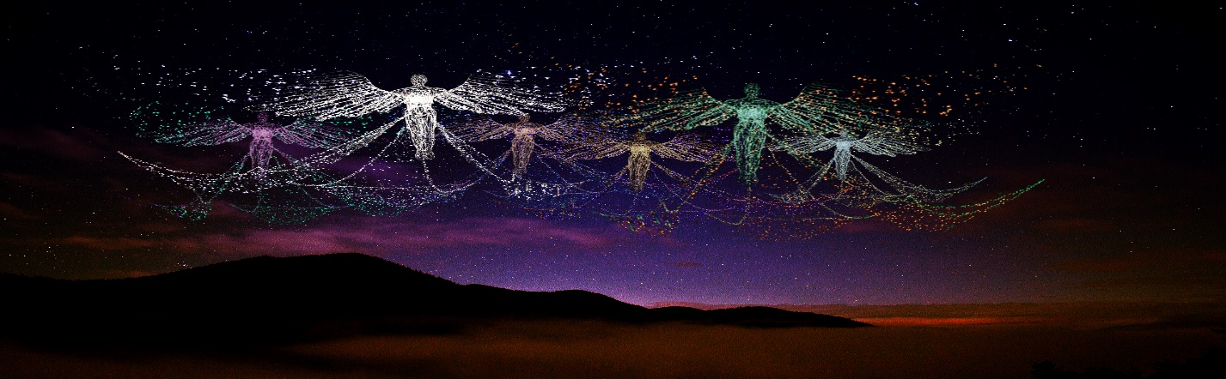

Advent 3 Sunday December 12th
Angels from the Realms of glory: verse 3
Sages leave your contemplations
Brighter visions beam afar
Seek the great Desire of Nations
Ye have seen His natal star
Come and worship, come and worship
Worship Christ the newborn King
Matthew 2: 1 - 9
In the time of King Herod, after Jesus was born in Bethlehem of Judea, wise men from the East came to Jerusalem, 2asking, ‘Where is the child who has been born king of the Jews? For we observed his star at its rising and have come to pay him homage.’ 3When King Herod heard this, he was frightened, and all Jerusalem with him; 4and calling together all the chief priests and scribes of the people, he inquired of them where the Messiah was to be born. 5They told him, ‘In Bethlehem of Judea; for so it has been written by the prophet:
6 “And you, Bethlehem, in the land of Judah,
are by no means least among the rulers of Judah;
for from you shall come a ruler
who is to shepherd my people Israel.”
7 Then Herod secretly called for the wise men and learned from them the exact time when the star had appeared. 8Then he sent them to Bethlehem, saying, ‘Go and search diligently for the child; and when you have found him, bring me word so that I may also go and pay him homage.’ 9When they had heard the king, they set out; and there, ahead of them, went the star that they had seen at its rising, until it stopped over the place where the child was.
Candle Lighting
In the ordinary moments of our lives
When thoughts, distractions
And busyness might keep us apart
Open our hearts to let you in
When you stand before us
As angel or stranger and speak to us
In the hearing and understanding of your word
Open our hearts in obedience to your will
Advent God, you enter time and lives
and transform both
to the glory of your name
and the benefit of all people.
On this third Sunday of Advent
we praise your name
for Angel voices and obedient hearts. Amen
Adapted from https://www.faithandworship.com/Advent/Advent_Angels.htm#gsc.tab=0
AT HOME
A Prayer………
God, the message of the angels of Bethlehem was true.
Good news of great joy came with Jesus’ birth,
with his life, with his sacrifice for us,
and with his glorious resurrection, also announced by angels.
We wait so hopefully for great joy.
Open our eyes to the angels who walk among us,
caring for the sick, comforting the brokenhearted,
standing up for those whose voices are silenced,
doing the hard and holy work of bringing your peace on earth.
Thank you that you have never stopped sending angels.
Help us to be angels, heralds of love,
believing in your power to bring down the mighty,
believing that truth will triumph over lies,
and that hated will never have the last word.
Help us this week to resist the power of lies,
the ones we tell ourselves,
and especially the ones we tell our loved ones.
Lying is so easy and simple to do, and so devastating.
We pray especially today for the peace of Jerusalem.
A holy city for so many, it is torn by tension,
and just as when Jesus was born,
giant empires dictate its rise and fall.
Raise up peacemakers who can speak truth to power,
and unmask violence of every type.
Thank you for the way you are entering into our world
every day, being born again in the humblest of places,
wherever love shines.
Come, Lord Jesus.

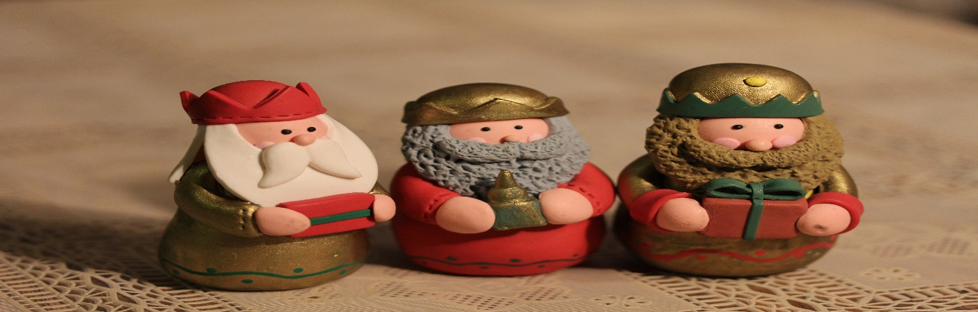
A thought…….
Weird strangers, Out of place in Bethlehem
Weird strangers, out of place in Bethlehem,
Stargazers from another place and time;
What triggered these perceptive, ancient men?
What added their incongruence to this rhyme?

Their dissonance brings colour to the scene,
Their clothes of silk, their rich symbolic gifts;
What once had been a rural, rustic scene,
Is royal, regal, as perception shifts.

No ragged child is born amid the herd,
The ground of all existence is alive.
Our God is come! The story is absurd:
As exiled parents struggle to survive.

By Andrew Pratt from ‘shine on, star of bethlehem’

What message does this song signal to you?

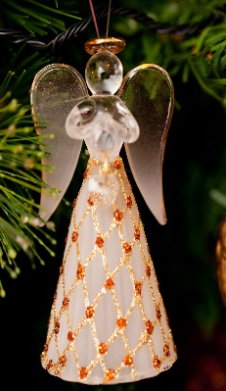

Advent 4 Sunday December 19th
Angels from the Realms of glory: verse 4
Saints before the altar bending
Suddenly the Lord, descending,
In His temple shall appear
Come and worship, come and worship
Worship Christ the newborn King
Revelation 8: 3,4
3 And another angel came and stood at the altar with a golden censer, and he was given much incense to offer with the prayers of all the saints on the golden altar before the throne, 4 and the smoke of the incense, with the prayers of the saints, rose before God from the hand of the angel.
Candle Lighting
In the ordinary moments of our lives
When thoughts, distractions
And busyness might keep us apart
Open our hearts to let you in
When you stand before us
As angel or stranger and speak to us
In the hearing and understanding of your word
Open our hearts in obedience to your will
You break in
When defences are down
With an Angel's shout
Or the quietest sound
You break in
Advent God, you enter time and lives
and transform both
to the glory of your name
and the benefit of all people.
On this fourth Sunday of Advent
we praise your name
for Angel voices
and obedient hearts.
Amen
Adapted from https://www.faithandworship.com/Advent/Advent_Angels.htm#gsc.tab=0

AT HOME
A prayer…….
Because of Jesus,
we know that God takes notice of us,
cares about us day by day,
loves us, calls us,
and is always with us.
Sing it with your lips,
and believe it in your heart,
as Christ the Saviour is born. Amen.
From Advent, Christmas and Epiphany by Brian Wren
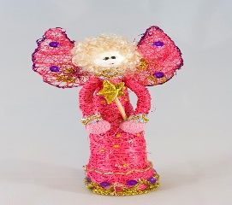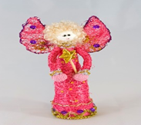
A thought…….
TWO WINGS
An angel
is a bit like a tooth fairy
but it does not collect teeth.
An angel is a good person,
but,
maybe it is not.
An angel has two wings and it wears pink,
but,
it might not.
An angel is a dead person, that’s definite.
I think when you are dead you pass a test.
You go down to earth and do good things for the best.
You help somebody in need.
That means doing good deeds.
If you get all the deeds right
then you can be an angel and fly at night.
It’s my dream to see a real angel.

Adam Pearson, Aged 10

First published on a poster to celebrate the installation of ‘The Angel of the North’, a sculpture in Gateshead
From Acorns and Archangels by Ruth Burgess

What does an angel look like to you?
Christmas Day Saturday December 25th
Angels from the realms of glory
Wing your flight over all the earth
Ye, who sang Creation's story
Now proclaim Messiah's birth
Come and worship, come and worship
Worship Christ the newborn King
Shepherds in the fields abiding
Watching over your flocks by night
God with man is now residing
Yonder shines the Infant light
Come and worship, come and worship
Worship Christ the newborn King
Sages leave your contemplations
Brighter visions beam afar
Seek the great Desire of Nations
Ye have seen His natal star
Come and worship, come and worship
Worship Christ the newborn King
Saints before the altar bending
Watching long in hope and fear
Suddenly the Lord, descending,
In His temple shall appear
Come and worship, come and worship
Worship Christ the newborn King
Matthew 1:18 – 25
18 Now the birth of Jesus the Messiah* took place in this way. When his mother Mary had been engaged to Joseph, but before they lived together, she was found to be with child from the Holy Spirit. ¹⁹Her husband Joseph, being a righteous man and unwilling to expose her to public disgrace, planned to dismiss her quietly. ²⁰But just when he had resolved to do this, an angel of the Lord appeared to him in a dream and said, ‘Joseph, son of David, do not be afraid to take Mary as your wife, for the child conceived in her is from the Holy Spirit. ²¹She will bear a son, and you are to name him Jesus, for he will save his people from their sins.’ ²²All this took place to fulfil what had been spoken by the Lord through the prophet:
²³ ‘Look, the virgin shall conceive and bear a son,
and they shall name him Emmanuel’,
which means, ‘God is with us.’ ²⁴When Joseph awoke from sleep, he did as the angel of the Lord commanded him; he took her as his wife, ²⁵but had no marital relations with her until she had borne a son;* and he named him Jesus.
Candle Lighting
In the ordinary moments of our lives
When thoughts, distractions
And busyness might keep us apart
Open our hearts to let you in
When you stand before us
As angel or stranger and speak to us
In the hearing and understanding of your word
Open our hearts in obedience to your will
You break in
When defences are down
With an Angel's shout
Or the quietest sound
You break in
On this Christmas Day
we praise your name.
The angels' song rings in the air,
a child has been born.
Hallelujah!
The Saviour of the world is here.
Amen
Adapted from https://www.faithandworship.com/Advent/Advent_Angels.htm#gsc.tab=0

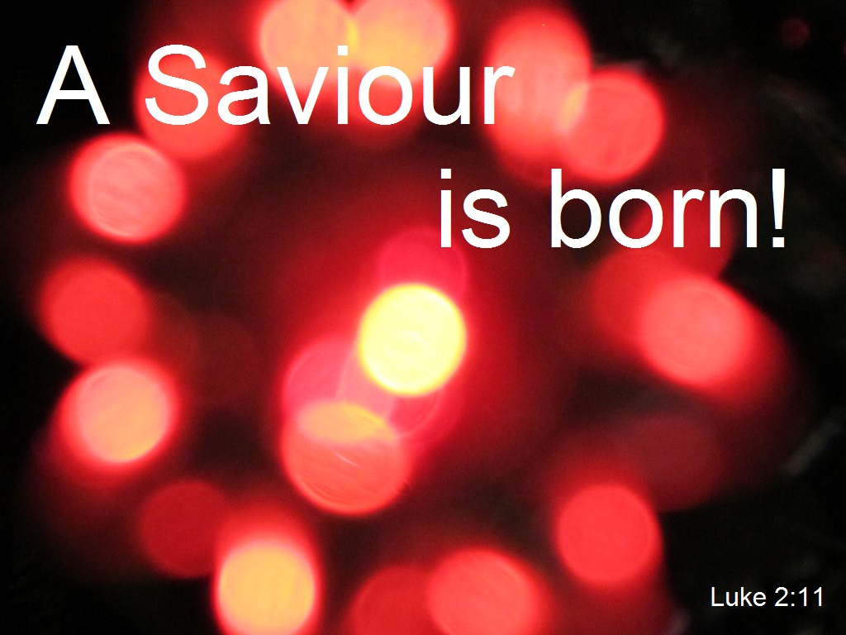

AT HOME
A prayer…….
A time for welcoming the Prince of Peace
These were the streets we walked as pilgrims,
passing by the market stalls and praying at the stations of the cross.
Here was the wall of wailing where past destruction was remembered
and here the reading of a million names of children murdered
and a thousand candle lights to pierce the darkness in remembrance.
Yet in the same city now the noise of guns and bombs.
How can Jerusalem welcome the Prince of Peace?

Here are the shepherds’ fields we visited,
a place where even now we seem to hear the angels’ message.
Where the little town is busy with its visitors
and Manger Square is thronged with people
who make their way to the place of nativity.
Yet here too are armed soldiers and cries of hate.
How can Bethlehem welcome the Child of Peace?

Here in Nazareth the streets are busy down below
and settlements are sturdily built on the hills above,
there is water in the well where Mary heard the message
and it seems that even now you can hear the angel’s voice.
Yet Nazareth too has become a place of tension
and fear stalks the streets where the holy family lived.
How can Nazareth welcome the Child of Love?

The answer lies in reconciliation
and the true heart of religion’s message.
When God himself comes down amongst us,
then enmity is overcome and hate turned to love,
then the oppressed are lifted high and the poor are given hope,
for this is the time of Magnificat
and we too give joy-filled praise to the Prince of Peace.

By John Johansen – Berg from ‘shine on, star of Bethlehem’

A thought ……

Try to find a quiet place for a time of reflection:

The air is crisp and cold. You are sitting on a bleak hillside with some shepherds. A little fire burns nearby, a centre of warmth and comfort. In the distance, you can see one or two little lights twinkling and you know that in that direction is the town of Bethlehem, clinging to the side of a rocky escarpment. Taste the sharp, cold air and listen to the night sounds.

Suddenly, with no warning, the sky is lit up with an unearthly radiance and a mighty figure at the centre of the light speaks to you. ‘Don’t be afraid! I am here with good news for you, which will bring great joy to all people. This very day in David’s town your Saviour was born – Christ the Lord! And this will prove it to you; you will find a baby wrapped in swaddling clothes and lying in a manger.’

The radiant enfolds you and the sound of angels winging breaks in upon your ears. You are wrapped in awe and amazement. The sky darkens, the vision fades and silence falls. Then everyone begins to talk at once as you discuss what has happened. As one, you decide to go and see for yourself if what the angel has said is true.

Imagine your journey. It would take about an hour. First over rough ground then nearer the escarpment, over the field that once belonged to Ruth & Boaz, and lastly the back-breaking climb up the twisting track to the town. Once at the inn a hubbub of sounds and smells and busy people engulfs you. Then you are led to the stable. The door is open and you peer hesitantly inside. Yes, it’s a stable all right, but amongst all the mess, in the dim flickering interior, sits a young woman with a tiny scrap of humanity in her arms. There in, a palpable atmosphere of awe, you worship.

Night watches by Jennifer Martin

And pray….

I have often wanted to be at the stable where you were born, Lord Jesus. I too would have worshipped you and marvelled at all that eternity has done up in so small a bundle. It was a wonderful plan Lord, and I am so glad to be part of it even though only a small one. May I never forget your sacrifice in coming into the world to save me. Amen

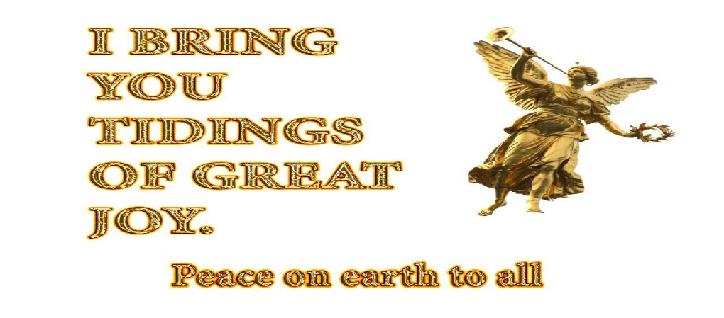
Happy Christmas, everyone

A compilation for Advent 2021 Karen Smith

